RAIN WATER HARVESTING CALUCLATOR

TEAM MEMBERS
1.Gurram Subhashini ( 25A31A0512)
2.Thota Sindhu Vijaya ( 25A31A0527)
3.Galla Subramanyam ( 25A31A0534)
4.Pemidi Sri mani Prasanna Raju ( 25A31A0555)

GUIDED BY
Mr.Manas kumar sir
Assistant Professor
Department of Computer Science and Engineering
Pragati Engineering College
Surampalem

1. Abstract
Rainwater harvesting is an effective method of collecting and storing rainwater for future use. This project presents a Rainwater Harvesting Calculator that estimates the amount of rainwater that can be collected from a rooftop area based on rainfall data. The system helps users understand how much water they can save using rainwater harvesting methods. The calculator takes inputs such as roof area, rainfall amount, and runoff coefficient to calculate the total amount of harvestable rainwater. This project is implemented using C++, and it provides a simple and efficient way to promote water conservation.

2. Introduction
Water scarcity is becoming a serious issue in many parts of the world. Rainwater harvesting is one of the most sustainable methods to conserve water. It involves collecting rainwater from surfaces such as rooftops and storing it for later use.
A Rainwater Harvesting Calculator helps estimate the quantity of water that can be collected during rainfall. By calculating the potential water collection, people can plan proper storage systems and reduce dependence on groundwater and municipal water supplies.

3. Project Description
The Rainwater Harvesting Calculator is a program that calculates the amount of rainwater that can be collected from a roof during rainfall.
The program requires three main inputs:
- Roof area (in square meters)
- Rainfall (in millimeters)
- Runoff coefficient (efficiency of collection)
Using these inputs, the program calculates the total water that can be harvested and displays the result in liters.
The system is implemented using C++ programming language and can be run on any basic computer system.

4. How the System Works
The system works by following a simple calculation formula used in rainwater harvesting.
Formula:
Water Harvested = Roof Area × Rainfall × Runoff Coefficient
Steps:
- User enters roof area.
- User enters rainfall amount.
- User enters runoff coefficient.
- The system performs the calculation.
- The result shows the amount of water that can be collected.

5. System Architecture
The system architecture contains three main components:
1. Input Module
- Takes user input such as roof area, rainfall, and runoff coefficient.
2. Processing Module
- Performs the calculation using the rainwater harvesting formula.
3. Output Module
- Displays the total harvested rainwater.
Flow:
Input → Processing → Output

- Flowchart
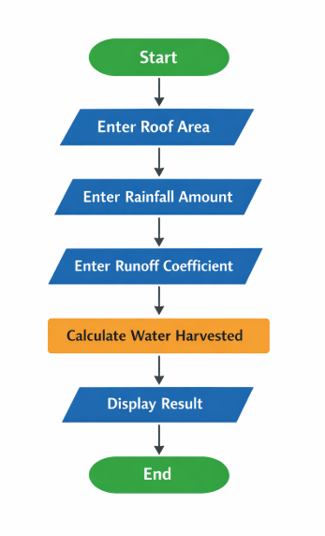

7. Flowchart Description
The program starts by asking the user to input the roof area. After that, the user enters the rainfall amount and runoff coefficient. The system then performs the calculation using the rainwater harvesting formula. Finally, the program displays the calculated amount of water that can be harvested and ends the process.

8. Algorithm
- Start the program
- Input roof area
- Input rainfall amount
- Input runoff coefficient
- Calculate water harvested using formula
- Display result
- Stop the program

9. Languages Used
The programming language used for this project is:
C++
C++ is used to:
- Take user input
- Perform calculations
- Display the result
It is efficient, simple, and suitable for basic calculation-based projects.

10. Advantages of the Project
- Promotes water conservation awareness
- Easy to use and simple calculation system
- Helps estimate rainwater collection potential
- Useful for homes, schools, and buildings
- Saves water resources

11. Disadvantages of the Project
- Requires accurate rainfall data
- Only provides estimation, not exact values
- Does not include real-time weather data

12. Applications
- Residential buildings
- Schools and colleges
- Agriculture planning
- Urban water management
- Environmental studies

13. Future Enhancements
- Integration with real-time weather data
- Mobile application development
- Graphical user interface (GUI)
- Automatic rainfall sensor integration
- Cloud-based data storage

14. Conclusion
The Rainwater Harvesting Calculator is a simple and effective tool to estimate the amount of rainwater that can be collected from rooftops. It helps people understand the importance of rainwater harvesting and encourages water conservation. By using simple inputs and calculations in C++, the system provides a useful estimation that can assist in planning rainwater harvesting systems.

